# 11. Objects Lab

**Tasks**

Download the starting files from Moodle for this lab.

There are no HTML or CSS files to write this week. You will just write the code in your JavaScript file to demonstrate the use of objects.

**Task 1 – Account Object**

**1. Create an account object**

The object should have the following properties:

* name, address, DOB (just the year), and balance. Assign each of them values.

**2. Create two functions for this object**

The object should have the following functions:

1. **getAge()**

Will return the age of the person. DOB is stored as a year, e.g., 1990. Therefore, this function will use the current year (constant) minus their DOB.

1. **getInterest()**

If the account has a balance of more than 1000, then the interest is calculated at 10%. Otherwise, the interest is 5%. Return the interest value.

**3. Call the Objects properties and Functions**

Lower in your JavaScript file, access the object’s properties and functions. Do this by writing to the console the object properties like below. Also, call the objects functions.

console.log( "Name: " + account.name );

**Task 2 – Car Object**

A more realistic example of using objects is when we create a new object by passing in some values for the object. We will now do this by creating a constructor function for the object.

I will demonstrate the code to achieve these tasks.

**1. Create a constructor function for a Car Object**

We will create a constructor function for our Car object. This function gets called automatically once we create a new Car object. This constructor function will take three parameters, which are make, model, and engine size.

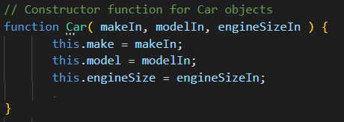

**2. Create a function for the Car Object**

I also want the Car object to have a function that will return the make and model of the Car. Therefore, I will add the following code.

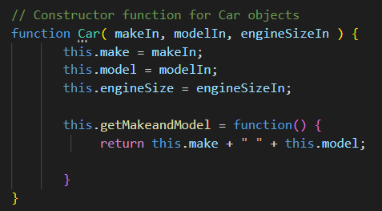

**3. Create a new Car object**

Next, I want to create two new Car Objects. I do this by using the code below.

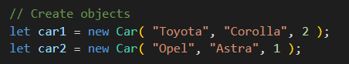

Finally, I want to call the Car Objects’ properties and functions.

